Isafjord, Iceland with Erasmus+ 2019

Sunday 31/3
Today we arrived in Reykjavik. We took off from Denmark at 4 am in the morning towards Copenhagen where we flew. When we came up here the weather was not very good it was raining and it was cold.
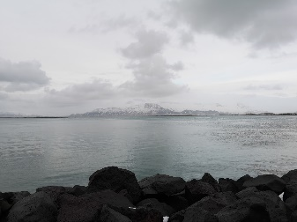

Monday 1/4
Monday morning we took a flight from Reykjavik to Isafjordur. When we arrived we drove to the school home and got our rooms, then we got a tour of the school.
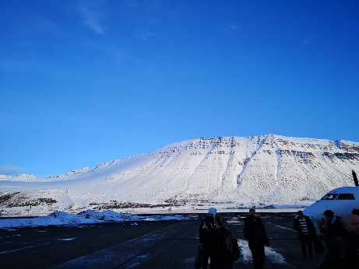

Tuesday 2/4
Today we were on a business visit at 3X where we were looking around. When we came back we had mathematics, we had to calculate the density of the things we need to do in the workshop.

Wednesday 3/4
We started to drive an hour by car, to get out and see an old workshop. When we had lunch we went to the school's workshop where we started making a toolbox.
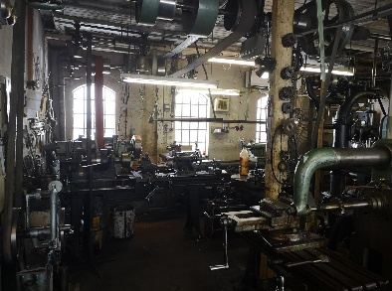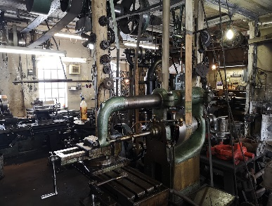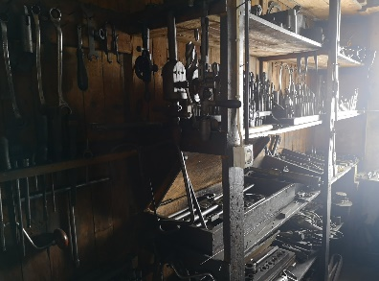

Thursday 4/4
Today we started writing a log-book and then we went to a workshop where we continued with our toolbox. In the afternoon we saw a dead whale lying in the fjord. We also saw a rescue and search team.
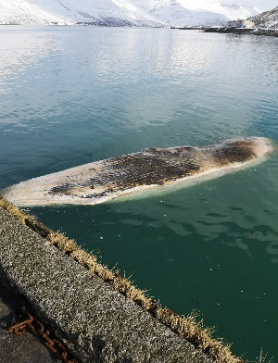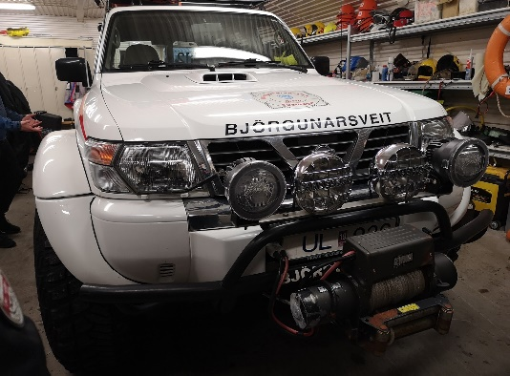

Friday 5/4
We have been in the workshop all day where we continued with our toolbox. When school was out some of us drove out to see a little more of Iceland's nature. In the evening we went to a show, an Icelandic comedy at school.
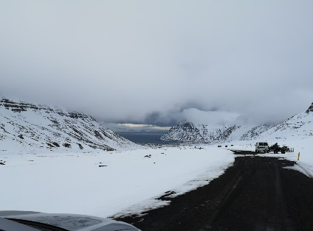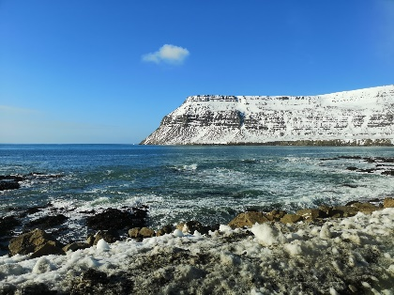

Saturday 6/4
Today we started with crossing over to another fjord. At 15:00 o'clock we went out to drive snowmobiles.
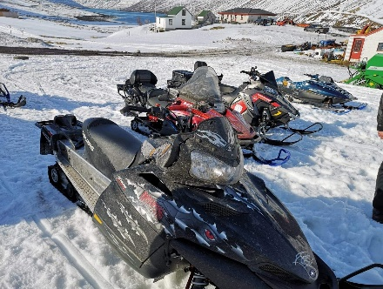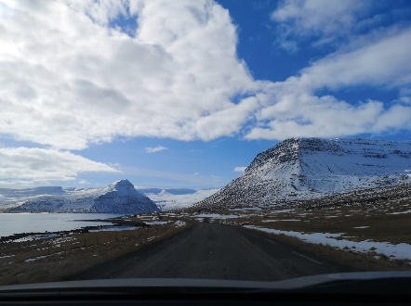

Sunday 7/4
We shouldn't do anything today. But I went for some trips to see Isafjordur.
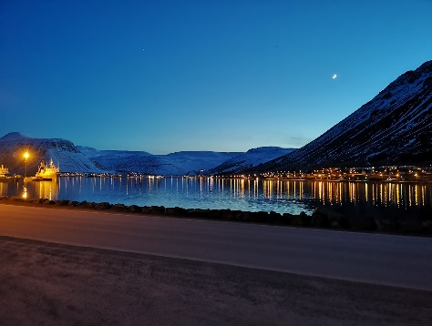

Monday 8/4
Today we were in the workshop all day, where we finished our toolboxes.
When we were finished we started making a mini grill.

Tuesday 9/4
Today we started writing in our logbook. Then we drove out to see the waterfall Dynjandi.
When we got home we relaxed.
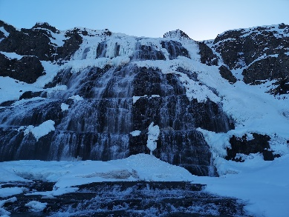

Wednesday 10/4
Today we were in the workshop all day we continued with the grill, so it was almost finished.

Thursday 11/4
Today we finished the grill. In the evening we went to a communal dinner at the school where there was music and comedy.

Friday 12/4
Today we started flying back to Reykjavik where we will be staying one day. When we arrived I went out to see the city.

Saturday 13/4
Today the trip returns to Copenhagen again we flew from Keflavik at 10:15 and was in Copenhagen at 15:15 after that we took a train home.

